4.11 Neuromuscular Junction

* **\*Neuromuscular Junction**: linkage of motor neurons and skeletal muscle fibres
  + Axon loses myelin, divides into many branches, and forms neuromuscular junction with one of the many muscle cells / fibres in the whole muscle
  + **Terminal button**: knoblike structure of the axon terminal
    - **Acetylcholine** released like in synapse, destroyed by acetylcholinesterase
  + **Motor end plate**: muscle cell membrane immediately under terminal button
    - **End-plate potential** (EPP): excitatory graded potential, much larger as
      * more neurotransmitter released
      * larger surface area and higher density of receptors
      * more channels open in respond to acetylcholine binding
    - magnitude of 1 EPP triggers AP (one-to-one from neuron to muscle)
  + EEP brings action potential in rest of muscle fibre, NMJ usually in middle
    - Action spreads from middle outwards => contraction!
  + **Acetylcholinesterase** (AChE): constant relaxation as ACh only binds briefly
    - As soon as ACh (neuron AP) stops muscle relaxes
  + **ONLY excitatory**, non inhibition (inhibition must be in CNS before NMJ)
* ACh related toxin:
  + Black widow spider venom: explosive release of ACh => prolonged depolarization (**depolarization block**, Na channels trapped in inactivated state) => respiratory failure (need alternating contraction and relaxation)
  + Botulinum toxin: blocks release of ACh => prevent muscles from responding to nerve => **botulism** (food poisoning, respiratory failure can’t contract diaphragm)
  + Curare: antagonist (binds to & block ACh sites) => respiratory paralysis
  + Organophosphates: inhibits AChE => respiratory failure (can’t repolarize)
  + Myasthenia gravis: disease that body produces antibodies against ACh receptors =>muscular weakness => fix by neostigmine (inhibits AChE temporarily)

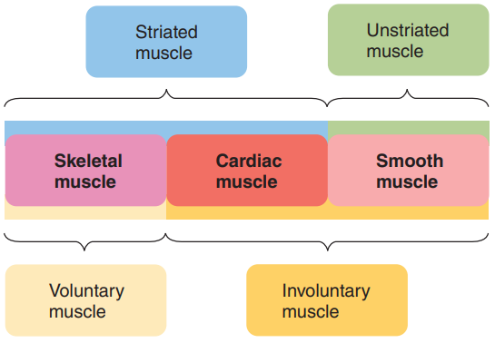7.1 Introduction (Muscles)

* **Striated**: whether alternating dark and light bands can be seen under microscope
* **Voluntary** (somatic nervous system) vs. **involuntary** (automatic)
* skeletal muscle ~ 40%, other 2 ~ 10%

7.2 Structure of Skeletal Muscle*

* **Muscle cells**: multiple nuclei & abundance of mitochondria

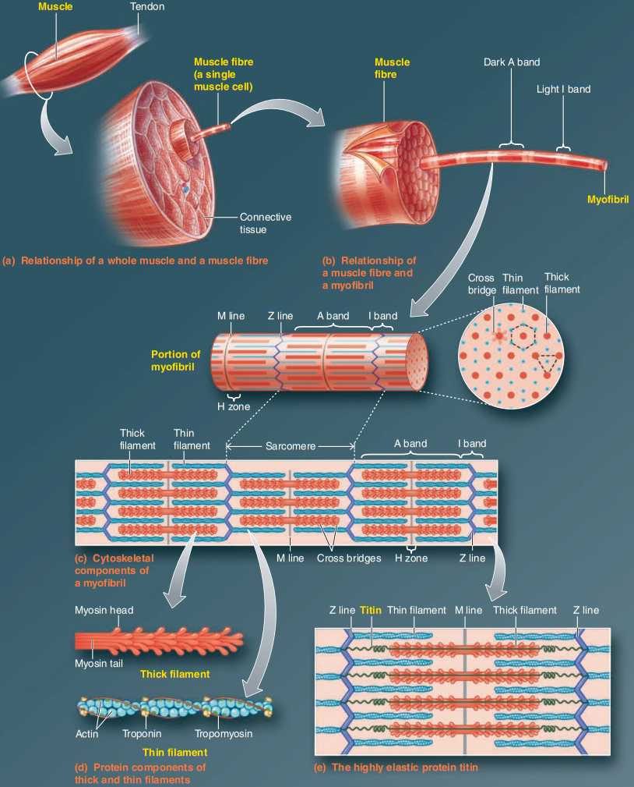

* Connective tissues: epimysium (whole muscle) => perimysium => endomysium (per cell)
* Sarcolemma: cell membrane of muscle cells
* Satellite cells: attached to muscle cells, muscle stem cells used for repair
* **Myofibril structure**: **Thick** and **thin** filaments, **myosin** and **actin** (contractile proteins)
  + **A band** (dark, anisotropic/scatters light): thick + thin filaments
  + **I band** (light, isotropic/light passes through): thin filaments only
  + **H zone**: thick filaments only; **M line**: proteins holding thick middle of H zone
  + **Z line**: proteins holding thin filaments middle of I band
  + **Titin**: spring like protein form M to Z line both directions, helps restoration
  + **Sarcomere** (functional unit): Z line to Z line, smallest contractable unit
    - Muscle growth: adding sarcomeres to ends of myofibril
  + Thick filaments have **cross bridges** (myosin heads), extending **hexagonally** corresponding to thin filament arrangement, as a result thick arrange **triangularly**
* 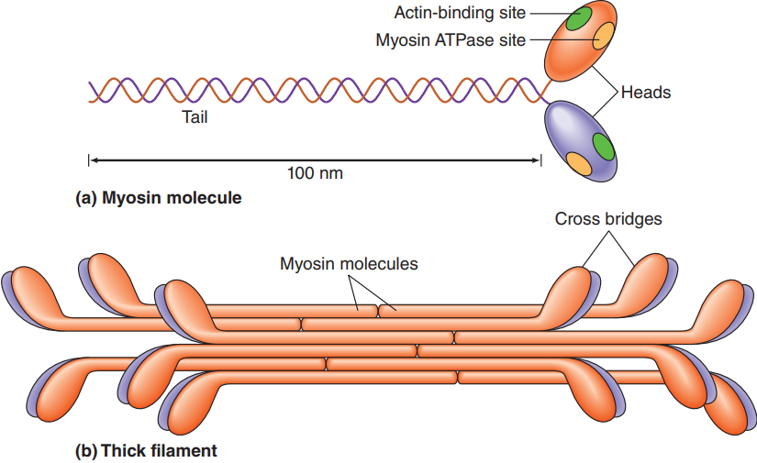**Myosin**: protein packed into thick filaments with tail in center and head outside
  + Each head (cross bridge) has two important sites for contraction:
    - **Actin-binding** site: binds to actin for contraction (power stroke)
    - **Myosin ATPase** (ATP-splitting) site: ATP => ADP + P
    - Rate of ATPase activity on head => muscle fibre typing
* Actin, tropomyosin, and troponin: made thin filaments, actin is primary structure
  + **Actin**: spherical, backbone of a thin filament => two strands twisted together
    - had binding site myosin cross bridge => result in contraction
  + Regulatory proteins:
    - **Tropomyosin**: wraps around actin backbone
    - **Troponin:** each polypeptide unit binds to actin, tropomyosin, and Ca
    - 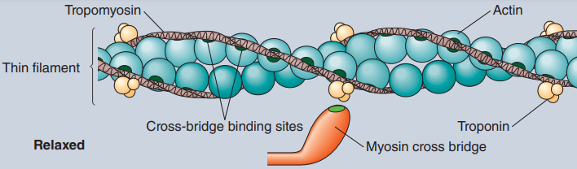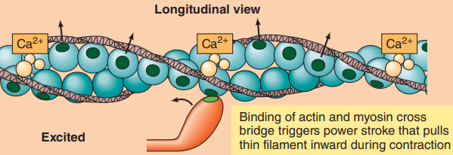Calcium triggers troponin to move away from blocking position, each troponin affects seven actin sites

7.3 Molecular Basis of Skeletal Muscle Contraction

* **Sliding filament mechanism** through **power strokes**
  + myosin heads repeatedly attach to actins and pull inwards (power strokes), so thin filaments slide inwards towards M line (concentric contraction / sliding filament)
    - 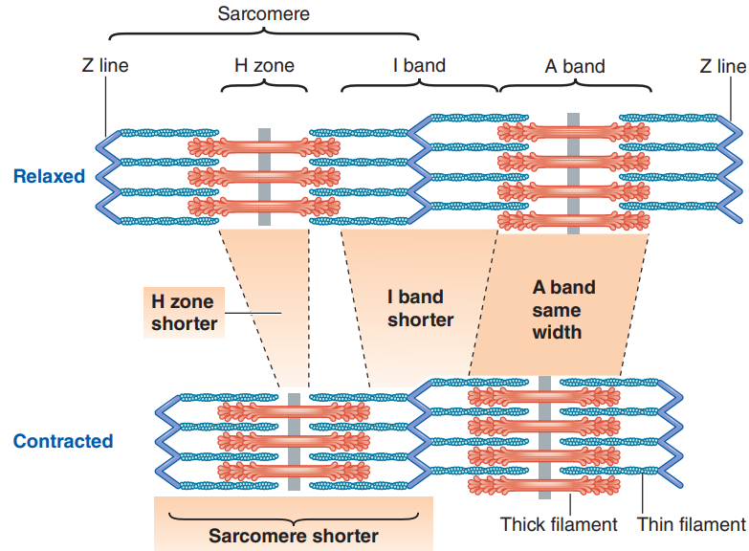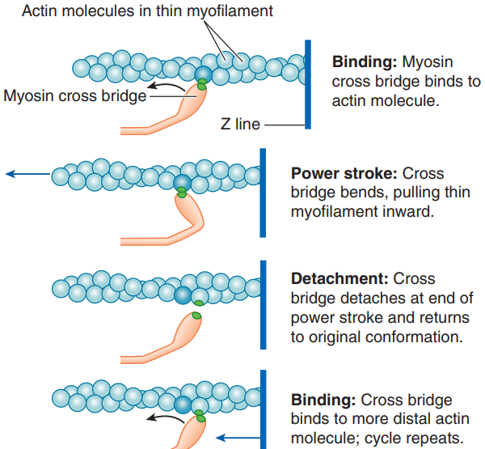6 heads stroke **asynchronously** (prevent bouncing back between strokes)
* **\*Excitation–contraction coupling**: links muscle excitation (AP) to muscle contraction
  + **Transverse tubules**: transport AP down to myofibrils in center of muscle cells
    - **dihydropyridine receptors**: voltage-gated, binds to half of the foot proteins (also 4 subunits), triggers another half to release Ca when AP
  + **Sarcoplasmic reticulum** (SR): modified ER
    - **Terminal cisternae** (lateral sacs) release Ca from **foot protein/ryanodine receptors** (4 subunits) after dihydropyridine receptors trigger it
    - 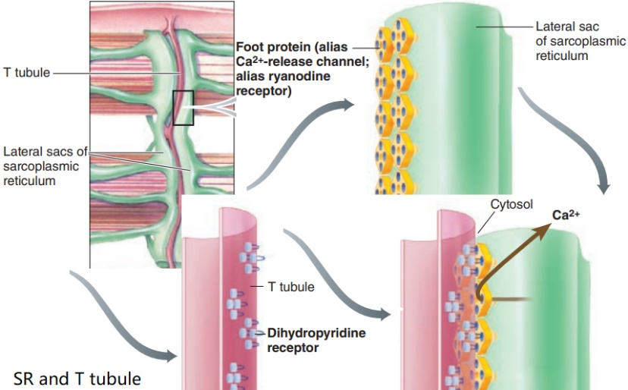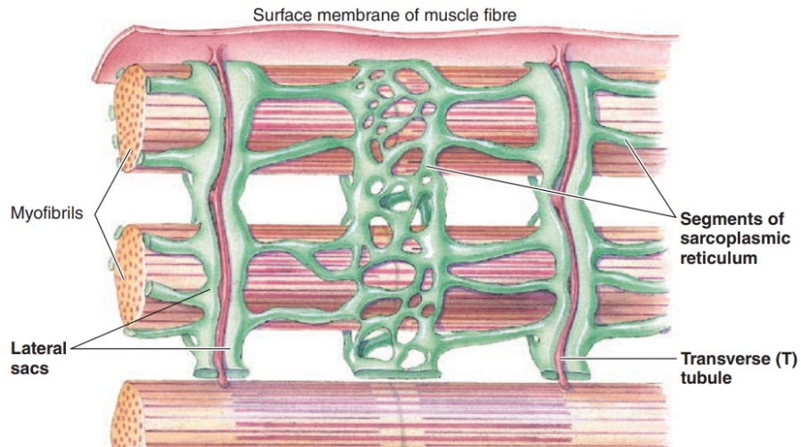SR has Ca–ATPase pump, which transports Ca from cytosol to lateral sacs
* **\*Cross-bridge cycling**: key factor is myosin ATPase & ATP
  1. Breakdown of ATP (energy) occur before biding to actin, “energetic/ready to fire”
  2. Didn’t found mechanism of how energy is stored & translated to power stroke
  3. Phosphate released during power stroke, ADP after
  4. When P and ADP are released, ATPase ready for another ATP
  5. ATP binding triggers detachment, go back to 1 (split ATP & bind to actin again)
* 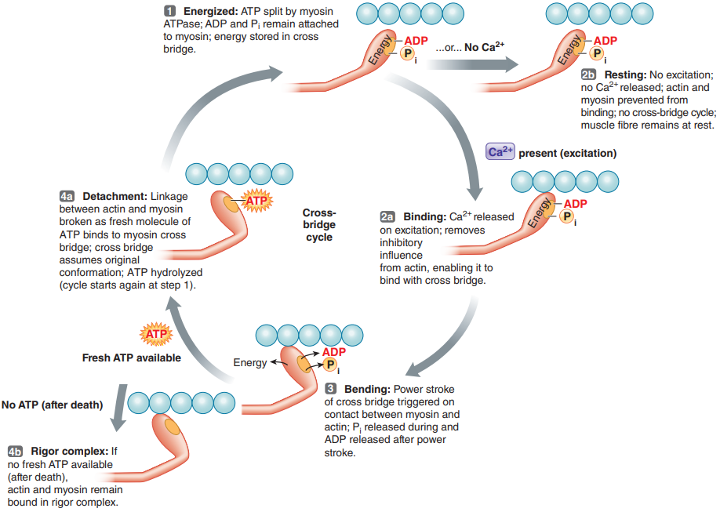**Relaxation**: SR actively takes up Ca & AChE takes up ACh (no contraction is relaxation)
* Time between AP and contraction: up to 100 ms for contraction vs 1-2 ms for AP
  + **Latent period** (~ 0.5 ms): time from AP to onset of contraction (ECC)
  + **Contraction time (~** 40–120 ms): time from onset of contraction to peak tension
    - depend on type of muscle fibre, fast twitch (FT) > slow twitch (ST)
      * ST has lower density of SR
  + **Relaxation time** (**~** 50–200 ms): time from peak tension to complete relaxation
    - (FT) > (ST), ST also has lower Ca re-uptake rate
  + All the delays are important for variable muscle strength?

7.4 Skeletal Muscle Mechanics

* **Whole muscle**: contains many (hundreds of thousands) muscle fibres, layers of connective tissues extend to form **tendons** which attach to bones
  + **Twitch**: contraction from single AP
* Contraction of whols muscle depends on mainly **number** of fibres and **frequency**
  + *Number of fibres contracting - **motor unit recruitment**
    - **motor unit**: motor neuron + all fibres it connects to
    - **size principle**: larger motor unit, harder to activate, stronger tension
    - **asynchronous recruitment of motor** units prevents **fatigue**
      * slow-twitch more resistant to fatigue
  + *Frequency of stimulation
    - **Twitch summation**:similar to temporal summation of EPSPs
      * possible since duration of AP << duration of twitch
      * twitch summation for a submaximal force => ~8-12 Hz
      * **Tetanus**: ~60 Hz, no time to relax – sustained maximal contraction, soon fatigues
      * Maximal contraction = enough Ca to keep all actin sites open
  + *Length of the fibre (at the onset of contraction)
    - **Optimal length** (): when thin filaments overlap all myosin heads, maximal force on next tetanic contraction (~quadratic graph)
      * In the body, relaxed length ~ optimal length
      * < : some heads can’t reach actin
      * > : actin overlaps, no room for pulling, less Ca release & bind
    - **Passive tension:** exponential increase when stretched too far (unrealistic)
  + Extent of fatigue: muscle / central fatigue
  + Thickness: hypertrophy (thicker fiber) => hyperplasia (split, more fibres)
* Muscle tension and bone
  + **Series-elastic components**: noncontractile tissues, spring between tension-generating elements (fibres) and bone
  + Muscle connects by tendons to at least 2 different bones across a joint
    - **Origin**: stationary end of muscle
    - **Insertion**: moving end of muscle
* 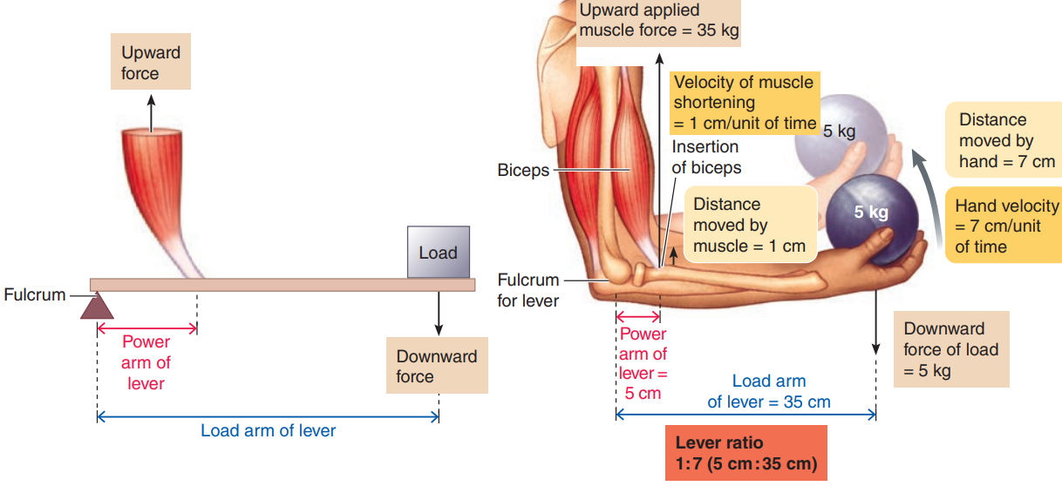Muscles, bones, and joints functions as lever
* Types of contractions:
  + Single fibre: **isotonic** (constant tension) vs **isometric** (constant length) vs other
  + Whole muscle: **static** (constant length, isometric) vs **dynamic** (moving)
    - **Concentric**: tension during shortening motion (lifting)
    - **Eccentric**: tension during lengthening motion (putting down weight)
* Velocity of shortening
  + Concentric: slower with load
  + Eccentric: faster with load
    - **Delayed onset muscle soreness**: caused by muscle damage from breaking cross bridges of actin & myosin molecules during eccentric with load
* Dynamic contractions create heat => warms the body

7.5 ATP and Fibre Types

* Contractile use of ATP – in SR for Ca transport and inmyosin
* Fatigue
  + **Muscle fatigue** (peripheral fatigue): muscles no longer respond to stimulation with same degree of contraction
    - Defence mechanism, protects from inability to produce ATP (rigor mortis)
    - Underlying causes of muscle fatigue are unclear
      * Local buildup of ADP interferes with crossbridge/Ca transport
      * Accumulation of lactic acid inhibits key enzymes
      * Accumulation of extracellular k reduces MP / decreases Ca release
      * Depletion of energy reserves
  + **Central fatigue**: CNS no longer adequately activates motor neurons while muscles can still perform, often physiologically based
    - Neuromuscular fatigue: inability to synthesize acetylcholine enough to sustain NMJ (produced experimentally but not under normal conditions)
* Muscle fibre types within a single motor unit
  + **Slow-twitch (type I) vs fast-twitch (type II)**: depends on motor input & ATPase
    - Type I – motor neurons, smaller => lower threshold & transmission; slow form ATPase (isoforms has same protein but alternative splicing)
    - Type II – motor neurons, larger => higher threshold & transmission; fast form ATPase
  + Table

    Description automatically generated**Glycolytic** (anaerobic) vs **oxidative** (aerobic): continuum
    - **Type I –** slow oxidative
    - **Type II -** fast oxidative glycolytic or fast glycolytic
    - **Red fibre** / oxidative fibres: both slow and fast, abundance of mitochondria and myoglobin (iron-oxygen & red like haemoglobin)
    - **White fibre** / fast glycolytic: specialized for glycolysis, few mitochondria but many glycolytic enzymes and glycogen (branched strand of glucose)